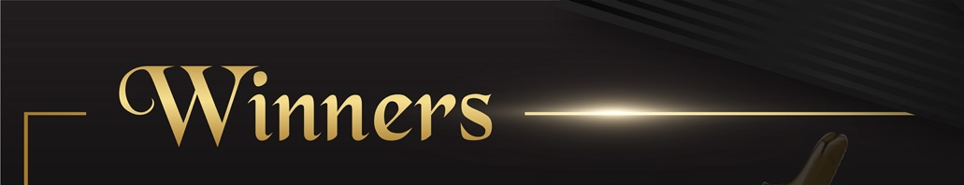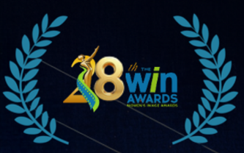
OUTSTANDING DRAMA SERIES
Lioness
OUTSTANDING ACTRESS DRAMA SERIES
Tracy Spiridakos Anna Pigeon
OUTSTANDING COMEDY SERIES
Hacks
OUTSTANDING ACTRESS COMEDY SERIES
Jean Smart Hacks
OUTSTANDING DOCUMENTARY FILM
Taurasi
OUTSTANDING MADE FOR TELEVISION MOVIE / LIMITED SERIES
Ride or Die
OUTSTANDING ACTRESS MADE FOR TELEVISION MOVIE / LIMITED SERIES
Hannah Waddingham Ride or Die
OUTSTANDING REALITY SERIES
Baylen Out Loud
OUTSTANDING ACTRESS REALITY SERIES
Baylen Dupree Baylen Out Loud
OUTSTANDING FILM OR SHOW WRITTEN BY A WOMAN
Lisa Lax & Nancy Stern Winters The Fighting Tiger
OUTSTANDING FILM OR SHOW PRODUCED BY A WOMAN
Octavia Spencer, Stephanie Kluft, Amy Lee-Jones, Verity Thomson, Christina Douglas, Lorna Thomas, Paris Peckerman Lost Women of Alaska
OUTSTANDING FILM OR SHOW DIRECTED BY A WOMAN
Lisa Joy Fallout “The Other Player”

