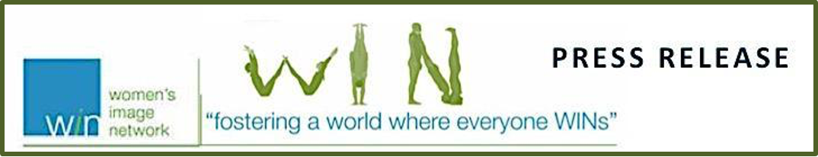

FOR IMMEDIATE RELEASE

THE WOMEN'S IMAGE NETWORK 27TH ANNUAL WOMEN'S IMAGE FEATURE FILM AWARDS ANNOUNCES ITS FILM NOMINEES & HONOREE & LET’S ROLL MOVIES THAT MOVE SHORT FILM OUTREACH

Los Angeles, CA – February 10, 2026.Now in year 27, Women’s Image Network (WIN) continues its long tradition of celebrating outstanding media that also promotes the value of women and girls. On Friday, February 27, 2026, Women's Image Network (WIN) will present feature film awards in five categories, one Let’s Roll indie short film and celebrate Community Activist Honoree Zibby Owens.

FEATURE FILM NOMINATIONS:

International Feature Film
Alpha FRANCE
All That's Left of You JORDAN
Sentimental Value NORWAY
Left-Handed Girl TAIWAN
The Voice of Hind Rajab TUNISIA
Actress International Feature Film
Cherien Dabis All That’s Left of You
Elle Fanning Sentimental Value
Golshifteh Farahani Alpha
Fernanda Torres I'm Still Here
Renate Reinsve Sentimental Value
Feature Film
Hamnet
The Testament of Ann Lee
Hedda
Sorry Baby
Director Feature Film
Mary Bronstein If I Had Legs I’d Kick You
Mona Fastvold The Testament of Ann Lee
Chloé Zhao Hamnet
Julia Ducournau Alpha
Actress Feature Film
Amanda Seyfried The Testament of Ann Lee
Jessie Buckley Hamnet
Emma Stone Bugonia
Laura Dern Is This Thing On?
(more)

Writer Feature Film
Mona Fastvold The Testament of Ann Lee
Chloé Zhao & Maggie O’Farrell Hamnet
HIKARI Rental Family
Mary Bronstein If I Had Legs I’d Kick You

For the first time in its 27-year history, we divided our television and film awards. Called LET’S ROLL, Celebrating Movies That Move, to support independent short filmmakers WIN will celebrate short films (under six minutes) with scenes of moving wheels. Filmmakers have until February 16th to submit their moving shorts. LET'S ROLL JURORS: Jordana Brewster, Natalie Kingston, Haley Watson, Laura Merian and Ryan Bahrke.

That same evening, WIN will present its Community Service tribute to LA Fire hero, author, publisher, podcaster and local bookstore owner, Zibby Owens (nee Schwarzman).

COMMUNITY ACTIVIST HONOREE: ZIBBY OWENS
Zibby Owens is a community builder and book trendsetter who employs purpose and authenticity to uplift voices and support emerging authors. Following the January 2025 Los Angeles fire, Zibby launched major relief efforts. To help displaced residents, she provided books from her Santa Monica bookshop inventory and secured clothing donations from dozens of brands like Citizens of Humanity, LoveShackFancy, and Draper James. Zibby also raised all funds needed to rebuild four Pacific Palisades school libraries, replenishing them with thousands of books.

Zibby curates the best books. An award-winning author of six books herself, including two bestsellers, On Being Jewish Now: Reflections from Authors and Advocates and Blank: A Novel, Zibby is CEO of Zibby Media, a multi-platform literary empire that includes Zibby’s Bookshop, an independent bookstore, and the daily podcast “Totally Booked with Zibby” (formerly “Moms Don’t Have Time To Read Books”). Zibby has interviewed First Lady and Senator Hillary Clinton, First Lady Jill Biden, Alicia Keys, Natalie Portman, and hundreds of New York Times bestselling writers. Her women-led boutique publishing house, Zibby Publishing, publishes books that make readers think and feel while elevating and celebrating authors. Zibby says, “My work is informed by a strong ‘why’ which must be bigger than just getting it done. We are changing people's lives. For me, that's the currency in which I speak.” A graduate of Yale University and Harvard Business School, Zibby lives in New York (and sometimes L.A.) with her husband and her four children.

About Women’s Image Network (WIN) For the first time in its 27-year history, WIN has divided its film awards from its television awards to perpetuate its gender parity goals. On November 9, 2025, The Women’s Image Network Awards 27 presented thirteen television tributes and celebrated honorees Patricia Clarkson, Gina Belafonte and Cecilia DeMille Presley. Founded in 1993 by artist Phyllis Stuart, Women’s Image Network creates, applauds and shares stories because powerful and excellent media builds inclusive and tolerant communities. For more information, please visit www.thewinawards.com, Email: Asst1@TheWINAwards.com or call 310-229-5365.

#####

