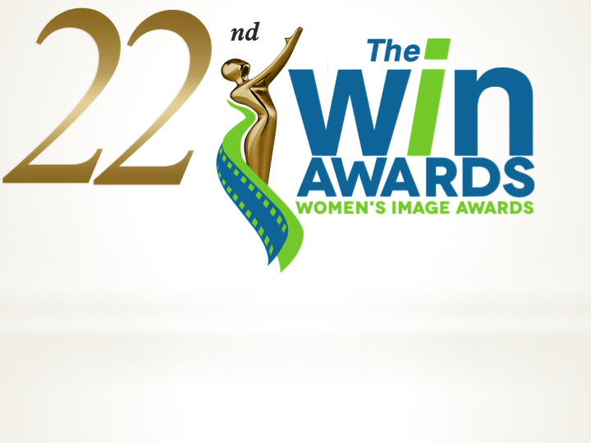
FOR MORE INFORMATION
Publicity Contact:

Leslie Campbell
310-229-5365
Asst1@thewinawards.com

* * * * FOR IMMEDIATE RELEASE * * * *

22nd ANNUAL WOMEN’S IMAGE AWARDS GOES VIRTUAL
* * *

October 20, 2020 (Los Angeles) The Women's Image Awards 22 will be virtually held for the first time in its twenty-two year history Thursday, October 22nd. Due to the pandemic WIN invited eight virtual presenters will pre-tape videos announcing the film and television nominees and winners. The virtual award presenters are: London Brown, (Ballers, Power), Katja Herbers, (Westworld, Evil), Rory Kennedy, (Ethel, Ghosts of Abu Ghraib), Helen Shaver, (Westworld, Vikings) Katheryn Winnick (Vikings), Melora Hardin, (The Bold Type) and Kate Flannery (The Office,). Elana Krausz (The Blackcoat's Daughter) will host.

On Thursday, October 22nd WIN will post these videos and share on social media sites.

The Women’s Image Awards 22 film and television nominees are:

Feature Film
Nomadland
I Am Woman
Misbehaviour
Horse Girl

Actress Feature Film
Tilda Cobham-Hervey I Am Woman
Danielle Macdonald I Am Woman
Julia Louis-Dreyfus Downhill
Frances McDormand Nomadland

Documentary Film
The Cave
Hillary
Blackfeet Boxing: Not Invisible
Who Will Write Our History

Made For Television Movie / Limited Series
Patsy & Loretta
Robin Roberts Presents: Stolen by My Mother: The Kamiyah Mobley Story
The Clark Sisters: First Ladies of Gospel
Dublin Murders

Actress Made For Television Movie / Limited Series
Sarah Greene Dublin Murders “Episode 4”
Aunjanue Ellis The Clark Sisters: First Ladies of Gospel
Megan Hilty Patsy & Loretta
Marcia Gay Harden Barkskins “Buttermilk”
Niecy Nash Robin Roberts Presents: Stolen by My Mother: The Kamiyah Mobley Story
Jessie Mueller Patsy & Loretta

Drama Series
How To Get Away With Murder “The Reckoning”
Power “Exactly How We Planned”
Outlander “Never My Love”
Good Trouble “Trap Heals”

Actress Drama Series
Monica Raymund Hightown “Love You Like a Sister”
Christine Baranski The Good Fight “The Gang Deals With Alternate Reality”
Caitriona Balfe Outlander “Never My Love”
Katja Herbers Evil “Book 27”

Comedy Series
Zoey's Extraordinary Playlist “Zoey's Extraordinary Glitch”
Atypical “Road Rage Paige”
The Bold Type “To Peg Or Not To Peg
One Day At A Time “Boundaries”

Actress Comedy Series
Aisha Dee The Bold Type “To Peg Or Not To Peg”
Katie Stevens The Bold Type “The Truth Will Set You Free”
Mishel Prada Vida “Episode 306”
Jane Levy Zoey's Extraordinary Playlist “Zoey's Extraordinary Glitch”

Reality Series
Surviving R. Kelly: Part II The Reckoning
Keeping Up With The Kardashians “The Show Must Go On”
Dr. Oakley, Yukon Vet “Squawk Off”
Crikey! It's the Irwins “Life in Lockdown"

Actress Reality Series
Dr. Michelle Oakley Dr. Oakley, Yukon Vet “Squawk Off”
Brie Bella Total Bellas “Babies On Board”
Terri Irwin Crikey! It's the Irwins ”Life in Lockdown"
Nikki Bella Total Bellas “Babies On Board”

Film / Show Produced by a Woman
Roberta Grossman, Nancy Spielberg, Anna Rózalska Who Will Write Our History Rebecca Cutter, KristieAnne Reed, Donna Bloom Hightown “Love You Like a Sister” Maril Davis, Toni Graphia, Alyson Evans, Shaina Fewell, Elicia Bessette, Caitriona Balfe Outlander “Never My Love"
Kirstine Barfod, Sigrid Dyekjær The Cave

Film / Show Written by a Woman
Samantha McIntyre Zoey's Extraordinary Playlist “Zoey's Extraordinary Glitch”
Sarah Phelps Dublin Murders “Episode 1”
Courtney A. Kemp Power “No One Can Stop Me”
Rebecca Cutter Hightown “Love You Like a Sister”

Film / Show Directed by a Woman
Chloé Zhao Nomadland
Katheryn Winnick Vikings “Vahalla Can Wait”
Karena Evans P-Valley “Perpetrain’
Marina Zenovich Lance
Melora Hardin The Bold Type “Snow Day”
Ann Druyan Cosmos: Possible Worlds “Coming of Age in the Anthropocene”
Christine Swanson The Clark Sisters: First Ladies of Gospel

The Women’s Image Awards, are a production of Women’s Image Network, WIN, and celebrate outstanding film and television that also promotes the value of women and girls. Since 1993, The Women’s Image Awards have celebrated both female and male directors, writers, producers and artists who compete in its fourteen categories.

#####

