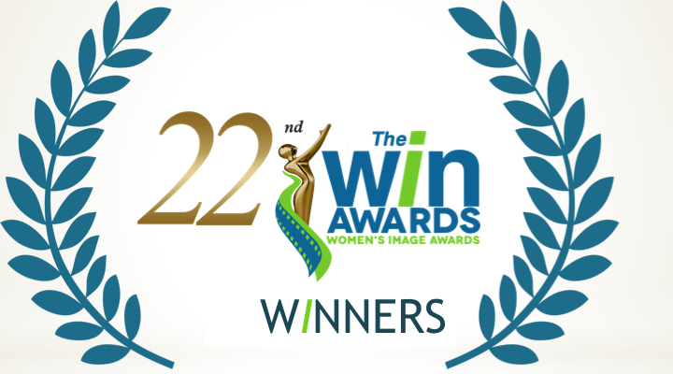
FOR MORE INFORMATION
Publicity Contact:
Joy Tuttle
310-229-5365
Info1@thewinawards.com

* * * * FOR IMMEDIATE RELEASE * * * *

Women’s Image Network Announces WOMEN’S IMAGE AWARDS WINNERS
* * *

October 23, 2020 (Los Angeles) The Women's Image Awards 22 were virtually conducted thanks to its eight virtual presenters who self-taped videos. Due to the pandemic WIN went virtual for The Women's Image Awards 22. Eight actors and directors self-taped videos to virtually present its film and television nominees and winners. The virtual presenters are: London Brown, (Ballers, Power), Katja Herbers, (Evil), Rory Kennedy, (Ethel, Ghosts of Abu Ghraib), Katheryn Winnick (Vikings, Big Sky), Melora Hardin, (The Bold Type), Helen Shaver, (Westworld, Vikings) Kate Flannery (The Office,) and Elana Krausz (The Blackcoat's Daughter).

The Women’s Image Awards 22 film and television winners are:

Feature Film Nomadland

Actress Feature Film Tilda Cobham-Hervey I Am Woman

Documentary Film The Cave

Made For Television Movie / Limited Series Patsy & Loretta

Actress Made For Television Movie / Limited Series Megan Hilty Patsy & Loretta

Drama Series Outlander “Never My Love”

Actress Drama Series Christine Baranski The Good Fight “The Gang Deals With Alternate Reality”

Comedy Series The Bold Type

Actress Comedy Series (tie)
Katie Stevens The Bold Type “The Truth Will Set You Free”
Jane Levy Zoey's Extraordinary Playlist “Zoey's Extraordinary Glitch”

Reality Series
Dr. Oakley, Yukon Vet “Squawk Off”
Actress Reality Series
Dr. Michelle Oakley Dr. Oakley, Yukon Vet “Squawk Off”

Film / Show Produced by a Woman
KristieAnne Reed, Donna Bloom, Ellen H. Shwartz Hightown “Love You Like a Sister”

Film / Show Written by a Woman
Samantha McIntyre Zoey's Extraordinary Playlist “Zoey's Extraordinary Glitch”

Film / Show Directed by a Woman
Katheryn Winnick Vikings “Vahalla Can Wait”

The Women’s Image Awards, are a production of Women’s Image Network, WIN, and celebrate outstanding film and television that also promotes the value of women and girls. Since 1993, The Women’s Image Awards have celebrated both female and male directors, writers, producers and artists who compete in its fourteen categories.

#####

