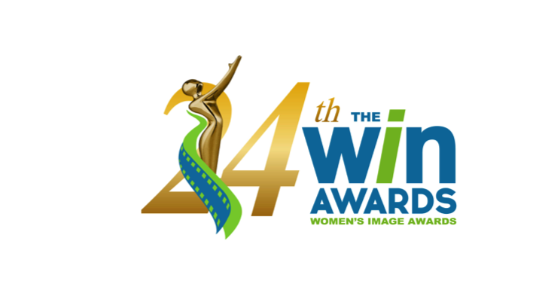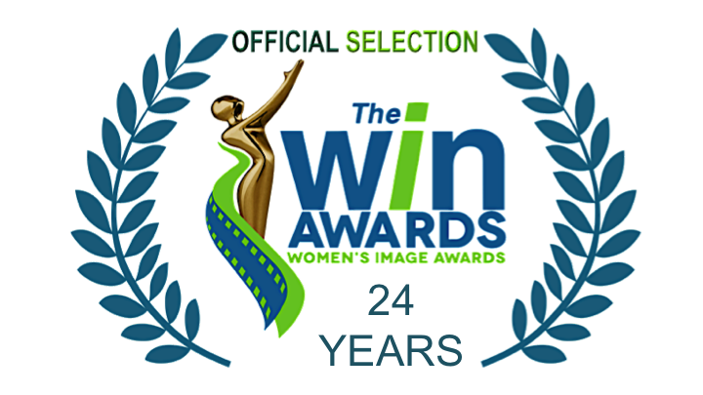

FOR MORE INFORMATION
Publicity Contact: Joy Tuttle
Phone / Email 310-229-5365 Info1@TheWINAwards.com

* * * * FOR IMMEDIATE RELEASE * * * *

WOMEN’S IMAGE NETWORK ANNOUNCES ITS HONOREE & NOMINEES
The 24th Women’s Image Award ceremony will present its 15 film and television awards
* * * *

October 10, 2022 (Los Angeles) Now in its 24th year, The Women’s Image Awards celebrate male and female media artists who create dimensional female media images, which also advance positive public opinion about the value of women and girls. The Women’s Image Awards ceremony is Thursday, November 10, 2022 in Los Angeles.

WHAT: The Women’s Image Awards 24
WHERE Los Angeles, California
WHEN Thursday November, 2022 RED CARPET 6:30PM / Ceremony 8PM

The Women’s Award Living Legend Honoree, actress Faye Dunaway has won the entertainment industry’s highest accolades including an Academy Award, three Golden Globes, a BAFTA, and an Emmy. Ms. Dunaway also received the Officer of The Order of Arts and Letters for her significant contribution to the enrichment of the French cultural inheritance. Regarded as one of the greatest actresses of her generation, Faye Dunaway was one of the leading actresses during the golden age of New Hollywood. A beautiful, elegant and bold blonde who plays complex, strong women, Faye Dunaway is an enormously popular actress who starred in films from the 1960s and beyond. Her film studio acting roles not only brought Ms. Dunaway top acting awards, but they taught her to how be Teflon during the height of the Hollywood boys club. Still standing today, Ms. Dunaway soon welcomes her 82nd turn around the sun and continues to create excellent theater, film and television.

The Women’s Image Awards 24 film and television nominees:
Documentary Film
Who Is Ghislaine Maxwell? (Starz)
Introducing, Selma Blair (Paramount+)
Janet Jackson (Lifetime)
Dream On (ESPN)

Made For Television Movie / Limited Series
Gaslit “Will” (Starz)
Zoey’s Extraordinary Christmas (The Roku Channel)
1883 “Season 1, Episode 1” (Paramount+)
List of a Lifetime (Lifetime)

(more)
Actress Made For Television Movie / Limited Series
Julia Roberts Gaslit “King George”
Faith Hill 1883 “Racing Clouds”
Isabel May 1883 “The Weep of Surrender”
Betty Gilpin Gaslit “Tuffy”

Drama Series
P-Valley “Mississippi Rule” (Starz)
The Cleaning Lady “TNT” (Fox)
Hightown “Great White” (Starz)
Power Book III: Raising Kanan “Back In The Day” (Starz)

Actress Drama Series
Patina Miller Power Book III: Raising Kanan “Paid In Full”
Natascha McElhone Halo “Solace”
Caitríona Balfe Outlander “Sticks and Stones”
Shannon Thornton P-Valley “White Knights”

Comedy Series
Shining Vale “Chapter 8 - We Are Phelps” (Starz)
Hacks “I Think She Will” (HBO MAX)
Welcome to Flatch “RIP Cynthia” (Fox)
Home Economics ”Camping Tent $39.99” (ABC)

Actress Comedy Series
Courteney Cox Shining Vale “Chapter 8 - We Are Phelps”
Jean Smart Hacks “I Think She Will”
Mira Sorvino Shining Vale “Chapter 8 - We Are Phelps”
Holmes Welcome to Flatch “That Old Flatch Magic”

Animation Program
HouseBroken “Who’s A Bad Girl? Part 2” (Fox)
It’s Pony “Saving Horse” (Nickelodeon)

Actress Animation Program
Lisa Kudrow HouseBroken “Who’s A Bad Girl? Part 2”
Jessica DiCicco It’s Pony “Saving Horse”

Reality Series
Love On The Spectrum “Episode #2.6” (Netflix)
Why Not Us Southern Dance "It’s Showtime, Boo" (ESPN)

Drama Series Writer
Tash Gray Power Book III: Raising Kanan “The Cost of Business”
Toni Graphia Outlander “The World Turned Upside Down”
Rebecca Cutter Hightown “Great White”
Katori Hall P-Valley “White Knights”

Comedy Series Writer
Emily Schmidt Welcome to Flatch “On The Hooky”
Julieanne Smolinski Home Economics “Camping Tent, $39.99”
Jenny Bicks Welcome to Flatch “RIP Cynthia”

(more)
Show Producer
Miranda Kwok, Melissa Carter The Cleaning Lady “TNT”
Nikki Toscano The Offer
Jennifer Flanz The Daily Show with Trevor Noah “Season 27, Ep. 87”
Rebecca Cutter Hightown “Great White”

Scripted Show Director
Ryan Case Home Economics “Camping Tent, $39.99”
Monica Raymund Hightown “Fresh As A Daisy”
Christina Alexandra Voros 1883 “The Fangs of Freedom”
Alethea Jones Shining Vale “Chapter 5 - The Squirrel Knew”

Non-Fiction Show Director
Dawn Porter 37 Words “Part 1”
Kristen Lappas Dream On
Nicole Newnham 37 Words “Part 4”
Allison Glock Home Field

About The Women’s Image Awards
To advance the value of women and girls, since its 1993 founding by actor and filmmaker, Phyllis Stuart, (Wild Daze, Becoming Bert Stern), Women's Image Network, (WIN), has produced The Women's Image Awards to celebrate artists whose work depicts dimensional female media images. ​

For tickets please email Asst1@TheWINAwards.com or call 310-229-5365.

#####

